Project Design Phase-II

Data Flow Diagram & User Stories

|  |  |
| --- | --- |
| Date | 20 October 2022 |
| Team ID | PNT2022TMID02412 |
| Project Name | Gas leakage monitoring and alerting system |
| Maximum Marks | 4 Marks |

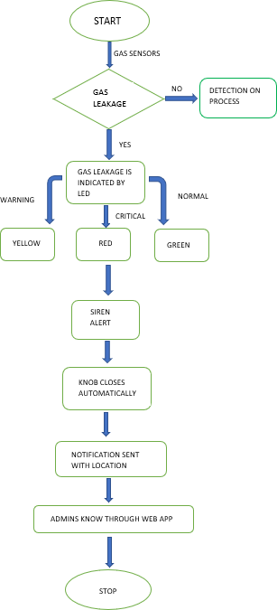

**User Stories**

Use the below template to list all the user stories for the product.

|  |  |  |  |  |  |  |
| --- | --- | --- | --- | --- | --- | --- |
| **User Type** | **Functional**  **Requirement (Epic)** | **User Story Number** | **User Story / Task** | **Acceptance criteria** | **Priority** | **Release** |
| Customer (Mobile user) | Registration | USN-1 | As a user, I can register for the application by entering my email address, password, and password confirmation. | I have access to my account and dashboard. | High | Sprint-1 |
|  |  | USN-2 | Once I have registered for the application, I will receive a confirmation email. | I received a confirmation email and clicked the confirm button. | High | Sprint-1 |
|  |  | USN-3 | As a user, I can sign up for the app using Facebook. | I can register and access the dashboard using my Facebook account. | Low | Sprint-2 |
|  |  | USN-4 | As a user, I can sign up for the application using Gmail. | I have access to the confirmation email. | Medium | Sprint-1 |
|  | Login | USN-5 | I can access the application as a user by providing my email address and password. | I have access to the confirmation email. | High | Sprint-1 |
| Customer (Web user) | Registration | USN-1 | As a user, I can sign up for the Google application. | I have access to the confirmation email. | High | Sprint-1 |
|  |  | USN-2 | As a user, I can sign up for the application using firebox. | Login confirmation is available to me. | low | Sprint-2 |
|  | Login | USN-3 | I can sign up for the application as a user using Gmail. | I have access to the confirmation email. | Medium | Sprint-1 |
| Administrator | Registration | USN-1 | I can sign up for the application as a user using a mobile app. | I have access to confirmation for My profile | High | Sprint-1 |
|  |  | USN-2 | I can sign up for the application as a user using a mobile app. | I have access to the confirmation email. | low | Sprint-2 |